Mitochondrial Physiology

Jäneda, 2017

9.30 - 10.00 Arrival and welcome coffee
10.00 - 10.05 Tuuli Käämbre Opening
10.05 - 10.40 Liliya Euro Computational approach to study mitochondrial DNA polymerase gamma
10.40 - 11.10 Marko Vendelin Restricted ADP movement in cardiomyocytes: Cytosolic diffusion obstacles are complemented with a small number of
open mitochondrial voltage-dependent anion channels
11.10 - 11.40 Juhan Sedman Maintenance of mitochondrial DNA
11.40 - 12.10 Priit Jõers mtDNA as a regulator of metabolism

12.10 - 12.40 Kalju Paju Bioenergetic studies of the biopsies taken from healthy and diseased persons at Tartu University Clinic
12.40 - 13.40 LUNCH
13.40 - 14.15 Sonata Trumbeckaite The role of mitochondria in ischemia/reperfusion injury of kidney
14.15 - 14.45 Allen Kaasik Mitochondrial Dynamics in Neuronal Development: Mechanism for Wolfram Syndrome
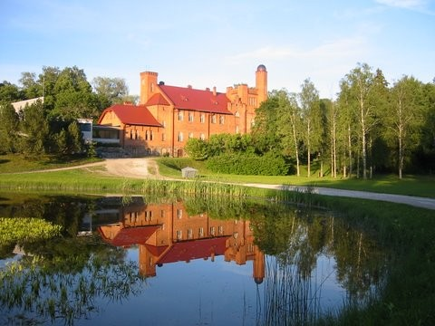
14.45 - 15.10 Merle Mandel Mitochondrial biogenesis is required for axonal growth
15.10 - 15.40 COFFEE BREAK
15.40 - 16.00 Aleksandr Klepinin Phosphometabolomics of human breast cancer
16.00 - 16.20 Ljudmila Õunpuu Bioenergetic profile of cancer stem cells
16.20 - 16.40 Andre Koit Quantifying metabolic alterations in human tumors
16.40 - 17.00 Discussion and concluding remarks

